AS 91893 Digital Media Outcome
Level 2 Digital Media · Student Documentation Template (Any project)
Use for any digital media outcome (web page/app UI, interactive media, etc.). Hub options include inventory tracker, finance learning tool, job board, or your own brief.
Student name | Oscar Berryman
Class / year | Year 12
Project title | Investment Decision Journal
Media type / stack | HTML, CSS, and Java
Teacher brief approved? | ☐ Yes
Date started | ________________________________

1. The problem
Who are the end users?
- The end users are people who are interested in investing, and want a clear, easy way to track their thesis across different stocks and investments.
What problem does the digital media outcome solve?
- The problem that the digital media outcome solves is the issue of people forgetting to review their theses on stocks as the market changes, this can lead to people not understanding what they hold, or becoming confused when their portfolio doesn’t represent their intentions.
What should users see/do when it works?
- An app that compiles/aggregates news articles, data and analyst ratings for stocks. Stocks specifically on the NSX and the ASX, Users can add their current holdings, and enter and update their thesis for stocks. They can add their bear and bull case, They can add their confidence level, They can add their predictions for future price levels and business data. Users set a date for review on their thesis that triggers a notification to help them stay consistent in their views. They can write a reflection / update holdings when the alert triggers, which turns can help them learn how to analyse better In the future. Review feature could also function as getting users to review their watchlist holdings, to see if the right time to buy for them has come yet. Clean portfolio dashboard with sector exposure by percentage

Ideation :
Homepage that looks something like this
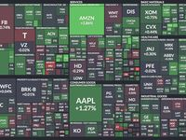
Review Urgency Heatmap
Tile size = portfolio weighting
Color = days until next review
- Green = recently reviewed
- Yellow = review due soon
- Red = overdue review
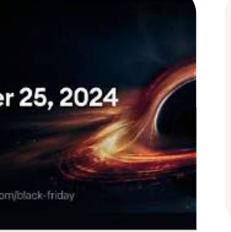
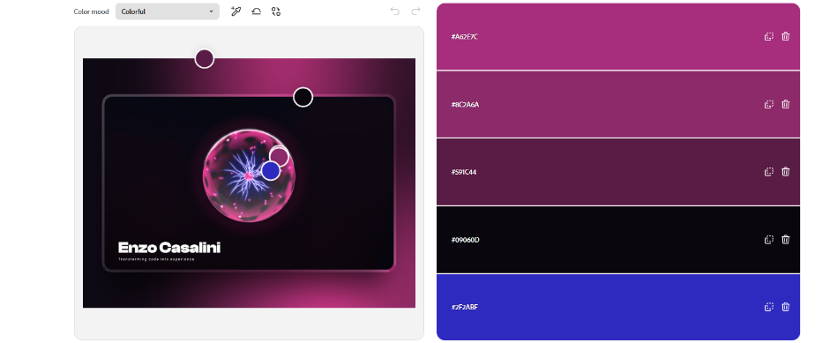

Color Palette Generator From Image | Adobe Express​
Enzo Casalini - Creative Developer Portfolio

Ai animated javascript blackhole inspired by the tradingview

P
Create a Palette - Coolors

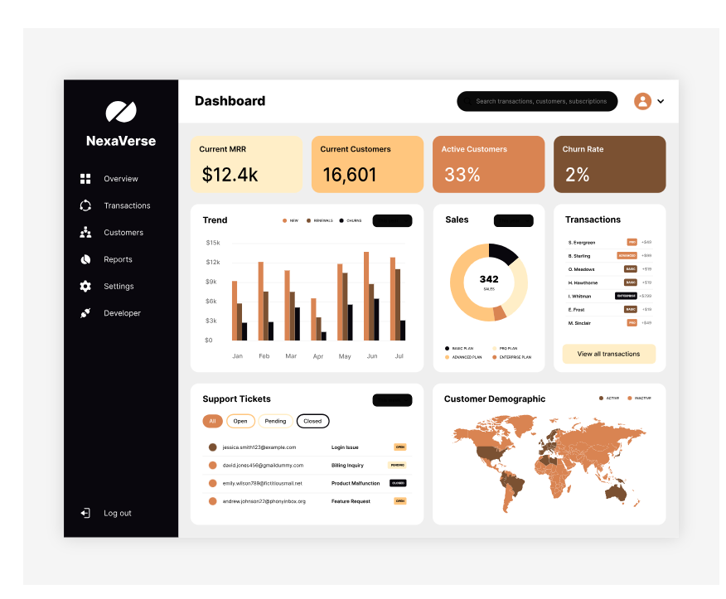
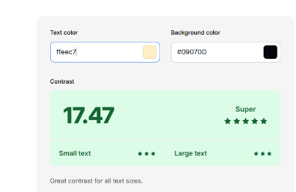
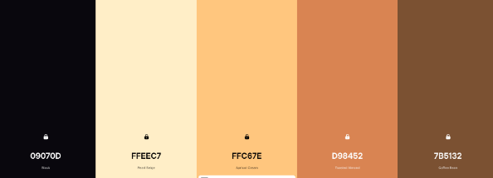
Colour palette testing:

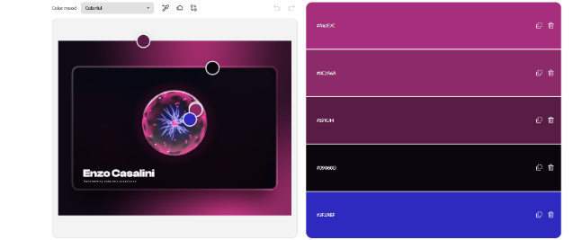
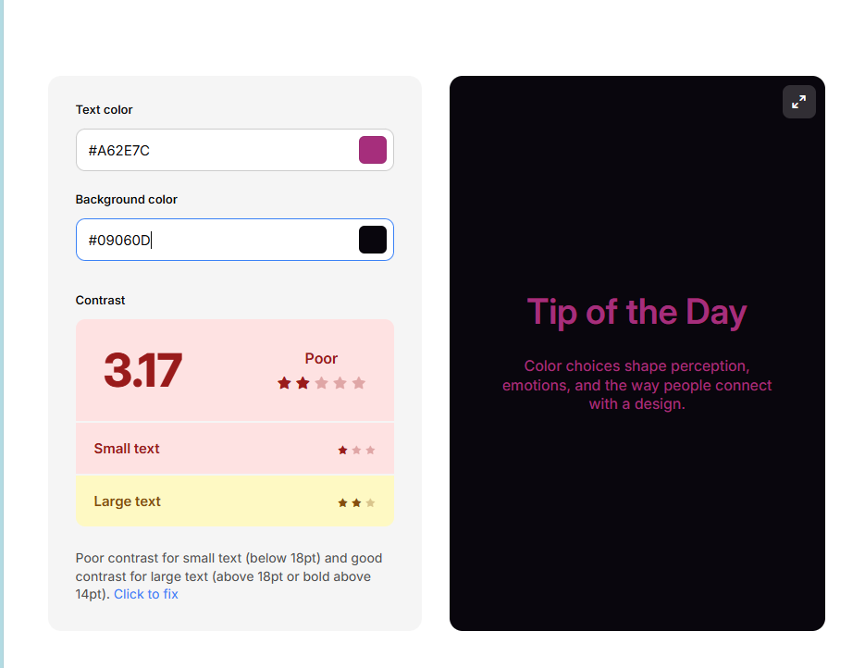

The obvious choice for my colour palette is the off-white-brown one. My aesthetic trailing already reported that users like the off-white-brown colour palette the best, and also think that it looks the most suitable for the topic of my website. The colour palette needs to be mature, because people may be using my journal to decide where thousands of their own dollars go, the pink would make it feel too game-afied. The contrast on the pink colour palette is also much worse than the off-white-brown one which is important because users need to be able to clearly read my website.

Advanced techniques
Mine? | Example advanced technique | What it might look like | Where in my project
☐ | CSS custom properties / themes | :root tokens for colour, space, type
☐ | Responsive layout system | Mobile-first flex/grid + breakpoints | I will use flexbox/ grid and media queries to make the interface adapt to the screen size.
☐ | Reusable UI pattern | Shared card/component classes or partials
☐ | Data-driven content | JSON/CSV mapped to visible UI | Json file to save users thesis parts. The data will be accessible in the users ‘saved theses’ box on the home page of the dashboard.
☐ | Scripts / interactivity | Custom JS for filters, tabs, states
☐ | Third-party library | Charts, icons, UI kit used with understanding
☐ | Asset pipeline / optimisation | Compressed images, sprites, consistent paths

Gaps I still need to add:

My ≥2 techniques for assessment:
- I am going to use a JSON file to track users investment thesis and options. I have chosen this because it allows me to record a lot of data, for different users and populate more than one html file with this data. I also like how easy it is to save things to it from my previous assessment.
- Responsive system layout using flexbox / grid to ensure my interface can be used on mobile devices and larger screens. This makes it more accessible to a greater amount of users, and especially casual investors which is most people.

Font testing:
Specification:
I want a font that looks clean, and minimalistic. Investment decisions should be about precision so a clear font will help make the user experience feel precise and calibrated.
Selection Embed Code - Google Fonts
Urbanist:
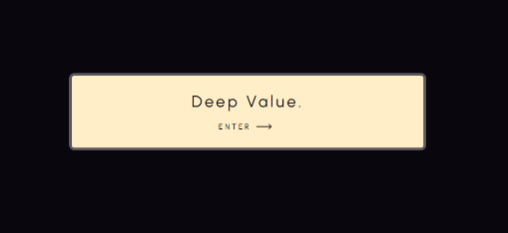
Sensation:
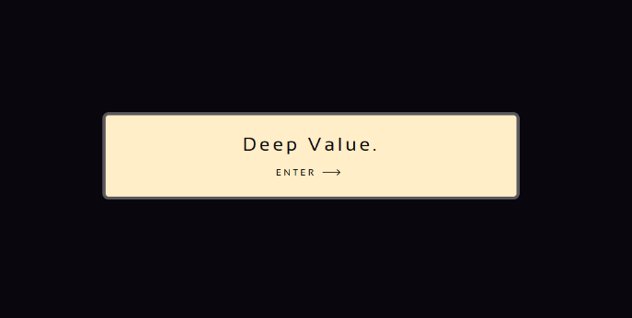
I chose to go with urbanist because I feel like the letter design feels more modern, sensation looks closer to a type writer. I also think that it looks a bit more rigid, the sensation letters are very square and that’s not what I want for a welcoming page. More rounded fonts make the user experience more inviting.

My selection:
- I chose the urbanist font because my aesthetic feedback reported that users liked it the most. I also like it too.

Implications
Implication | Why it matters for my users | How I addressed it (Merit+)
Accessibility | Because my app is designed for all investors it’s important that people with disabilities can use it. With increasing amounts of people interested in the stock market I think there will be a increasing amount of disabled people looking for an inclusive interface which allows them to invest like any other person, so making my interface accessible is a great way to capture this market. | I will design the project with high contrast between text and background, Titles for images for e readers – for the blind, the ability to magnify text, etc.  Specific examples:
Usability
Privacy / IP / ethics | Because making an investment decision journal requires inputting personal monetary decisions which could be considered quite private data its important that users privacy is kept | I will add a consent banner with options to accept / manage data management – like a cookies popup.  A disclaimer at the top of my new thesis form telling users that if they save their thesis it’s going to record their data.
Aesthetics / functionality
Other: ______

_______________________________________________________________________________________________
_______________________________________________________________________________________________
_______________________________________________________________________________________________
- I will do this by asking for permission for cookies and showing a disclaimer about data I will need to collect, and how it will not be shared.

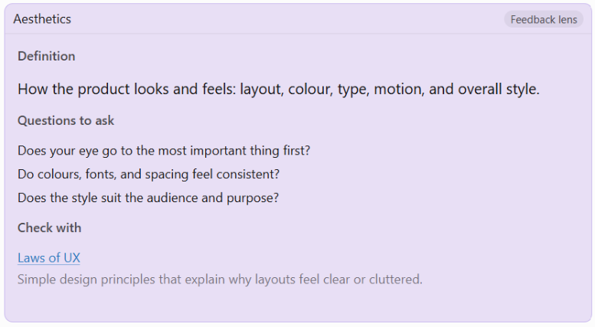

Early stage Feedback - Aesthetics

Name: Nikhil
Does your eye go to the most important thing first?
My eye was attracted to the glowing button first on the landing page, so yes I think so, on the home page they are drawn to colourful widgets first, which is good.
Do colours, fonts, and spacing feel consistent?
I think that it has a nice colour scheme. And there are some nice aminations that you have added from the nicegui. I like the urbanist font the most out of the two options.
Does the style suit the audience and purpose?
The colour scheme feels very mature which is perfect for an investment journal platform.
My nextsteps for you:
I think the next stop is adding a enter button or making it so you can enter your name by clicking the enter button on your keyboard. I also feel that you could make the writing a little bit bigger because there is so much space that isn’t really doing anything -

Name: Kevin – Year 11
My focus point – peer feedback – 11/08/2026
Does your eye go to the most important thing first?
It’s very neat, great lighting, cool halo button design, Great title, Pressing the button gives off full highlights. Cool Loading screen 10/10. Very neat so eyes don’t hurt/no distractions. So yes it does go to the most important thing.
Do colours, fonts, and spacing feel consistent?
Yes everything is spread out, it’s very consistent, all the buttons are smooth and working. Colours really work well together, the pumpkin orange colour gives of a luxury vibe.
Does the style suit the audience and purpose?
Yes as this website is designed towards people who like analysis and investing.
My nextsteps for you:
Put some more contents on the front of the page. I like the urbanist font the most out of the two options.

Name: Jake – Year 11
My nextsteps for you:
Add a stock searcher, you can search by ticker
Add a graph for each stock,
Keep title color the same
Sensation font is better

Name: Nikhil - Aesthetic and features feedback:
What my interface currently looks like:
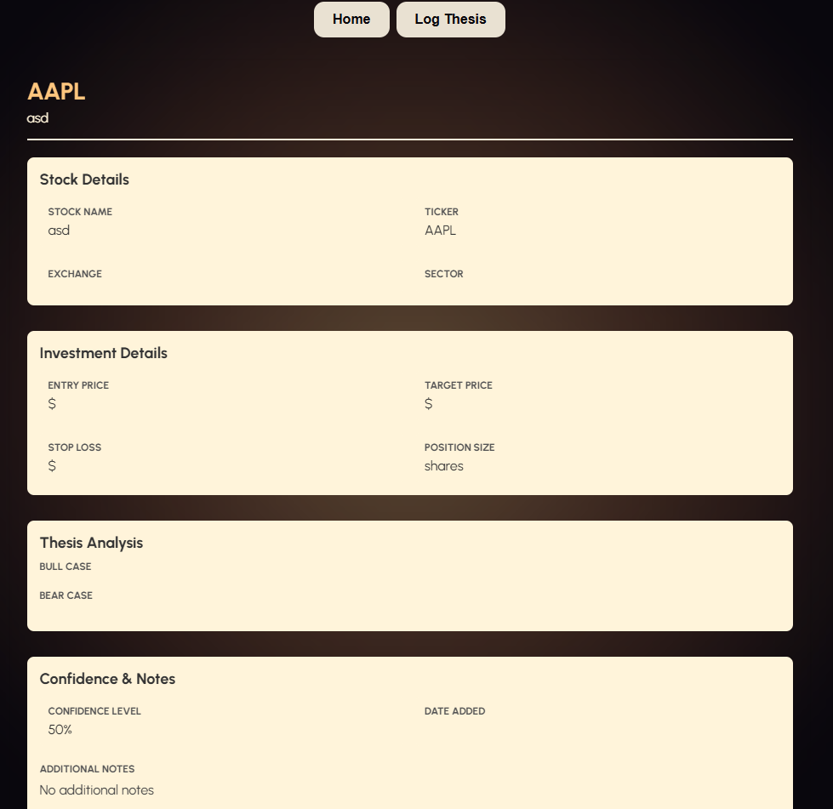
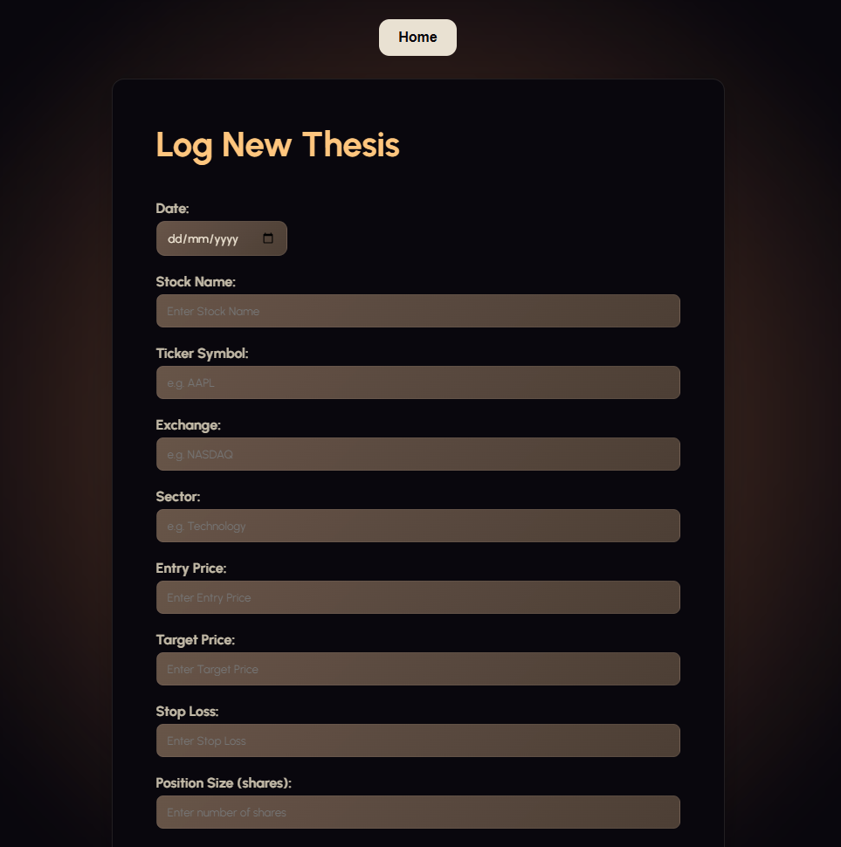
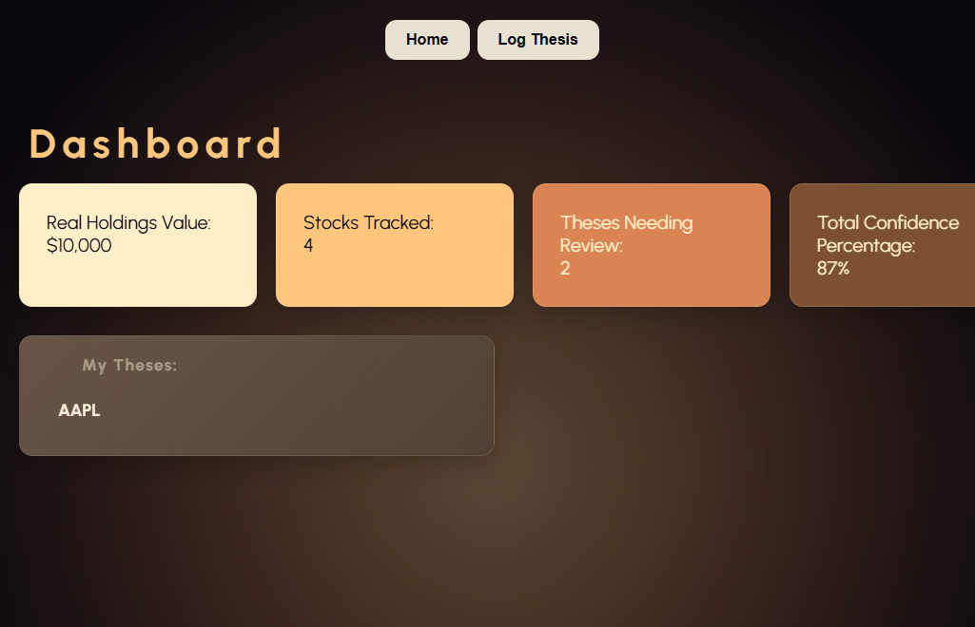

Two methods of project management for planning:
- https://www.figma.com/make/DsBcsbG96y2TW2J4hgVnID/Stock-research-app?t=hVCeLNTpkXmkmuug-1
- Comp Sci | Trello
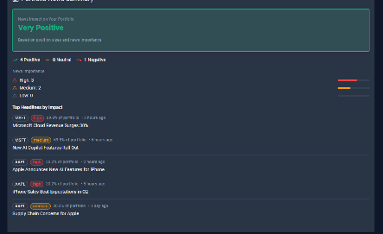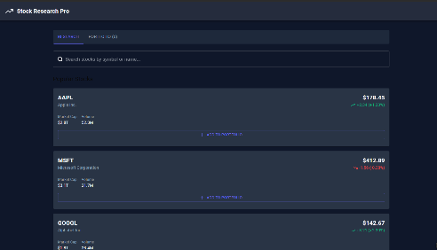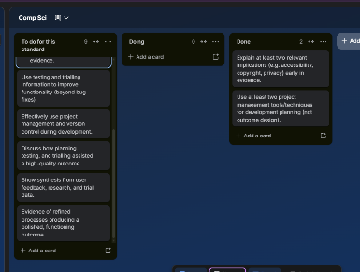
Required component breakdown:
- Interesting animation for the background
- Ability to input stock holdings by value and share size
- A wide variety of stocks to choose from
- Ability to input users own thesis, and record it
- Ability to send users notifications and set review dates for their thesis

